**14 - What is Low Code No Code Development**

Low-code and no-code are methods for quickly making apps with little to no coding. They simplify complex coding into easy-to-use visual tools, so regular business users can create apps without technical skills. At the same time, they help experienced developers speed up more complicated projects.

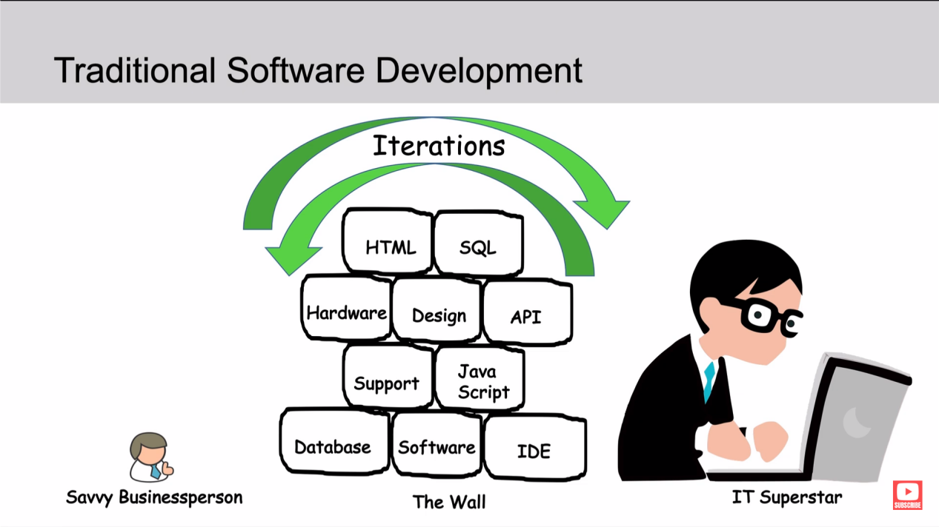

**Low Code No Code ServiceNow -**

App Engine Studio (AES) - A step-by-step tool for creating low-code and no-code apps. It helps with tasks like building tables, importing spreadsheets, setting up workflows, designing user interfaces, and managing security.

Studio - A more advanced tool for exploring and working with the components and features of applications. It functions as an Integrated Development Environment (IDE).

Now Experience UI Builder - A drag-and-drop tool for creating workspaces and portals.

Flow Designer - An easy way to automate workflows, approvals, tasks, notifications, and record operations using plain language, without needing to write code.

CMDB - A tool for understanding all IT infrastructure, serving as the foundation for building low-code and no-code apps.

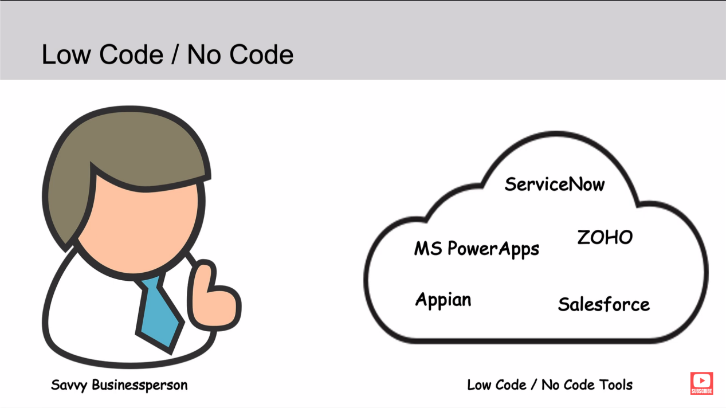

Companies like Microsoft (with PowerApps), Zoho, Appian, Salesforce, and ServiceNow all offer low-code and no-code features. These are just a few examples of the many companies entering the low-code/no-code space.

**Pros and Cons -** Low-code and no-code platforms offer several benefits. They empower business experts to address their own challenges, enhancing agility with tools that enable rapid development of IT services. This approach reduces costs by allowing more apps to be created quickly with less reliance on IT support and opens up greater opportunities for automation. However, these platforms also come with drawbacks. The need for generalization can restrict flexibility and limit opportunities for technical improvements that come with traditional coding.

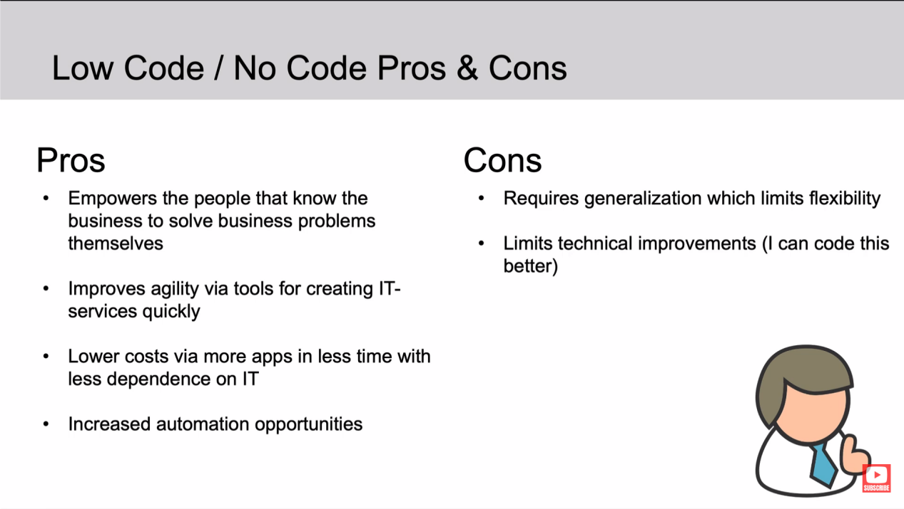

**Career Opportinities -** Career opportunities in IT require ongoing learning to fully grasp what technology can offer. As you gain more skills, it's important to start with simple projects and gradually tackle more complex ones. Understanding the business needs and how to integrate IT solutions effectively is key to leveraging technology responsibly and successfully.

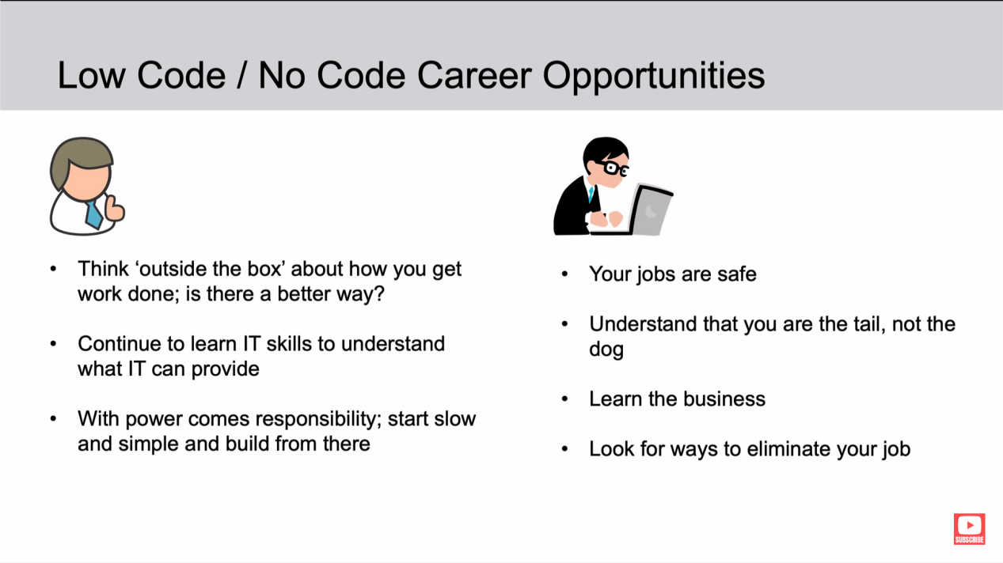

ANANYA CHOUDHARY